**MICRO CREDIT DEFAULTER PROJECT**

**Problems-**

This is a basic problem which helps Micro Financing Institutions & other lending companies reduce credit risks by recognizing potential defaulters.

**Background-**

Prior to the advancement of data science, lenders used to risk a high default rate. Several times, a perfect candidate would display erratic financial & repayment behavior once approved for the loan. Machine Learning can help lenders predict potential defaults before endorsing their application using their past data. The candidate’s income, past debt & repayment behavior can be important metrics for the same,

**Introduction-**

**A Microfinance Institution (MFI) is an organization that offers financial services to low income populations. MFS becomes very useful when targeting especially the unbanked poor families living in remote areas with not much sources of income. The Microfinance services (MFS) provided by MFI are Group Loans, Agricultural Loans, Individual Business Loans and so on. Many microfinance institutions (MFI), experts and donors are supporting the idea of using mobile financial services (MFS) which they feel are more convenient and efficient, and cost saving, than the traditional high-touch model used since long for the purpose of delivering microfinance services. Though, the MFI industry is primarily focusing on low income families and is very useful in such areas, the implementation of MFS has been uneven with both significant challenges and successes. Today, microfinance is widely accepted as a poverty-reduction tool, representing $70 billion in outstanding loans and a global outreach of 200 million clients. We are working with one such client that is in Telecom Industry. They are a fixed wireless telecommunications network provider. They have launched various products and have developed its business and organization based on the budget operator model, offering better products at Lower Prices to all value conscious customers through a strategy of disruptive innovation that focuses on the subscriber. They understand the importance of communication and how it affects a person’s life, thus, focusing on providing their services and products to low income families and poor customers that can help them in the need of hour. They are collaborating with an MFI to provide micro-credit on mobile balances to be paid back in 5 days. The Consumer is believed to be defaulter if he deviates from the path of paying back the loaned amount within the time duration of 5 days. For the loan amount of 5 (in Indonesian Rupiah), payback amount should be 6 (in Indonesian Rupiah), while, for the loan amount of 10 (in Indonesian Rupiah), the payback amount should be 12 (in Indonesian Rupiah). The sample data is provided to us from our client database. It is hereby given to you for this exercise. In order to improve the selection of customers for the credit, the client wants some predictions that could help them in further investment and improvement in selection of customers.**

**Problem Definition-**

Build a model which can be used to predict in terms of a probability for each loan transaction, whether the customer will be paying back the loaned amount within 5 days of insurance of loan. In this case, Label ‘1’ indicates that the loan has been payed i.e. Non- defaulter, while, Label ‘0’ indicates that the loan has not been payed i.e. defaulter.

**Analysis of the output of each model:-**

1. **LOGISTIC REGRESSION-**

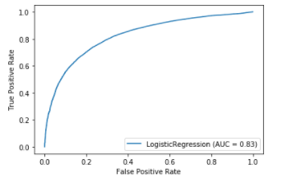 \

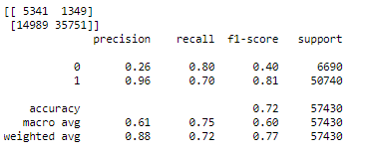

1. **SUPPORT VECTOR MACHINE(SVM)-**

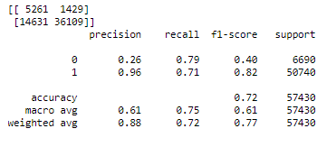

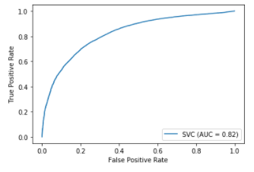

1. **DECISION TREE-**

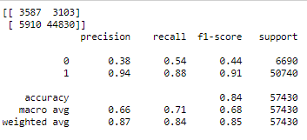

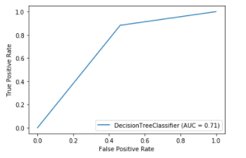

1. **RANDOM FOREST-**

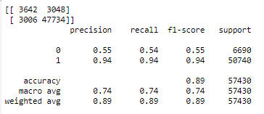

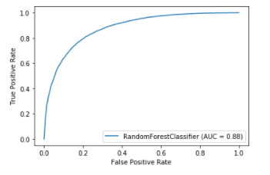

1. **GRADIENT BOOSTING CLASSIFIER-**

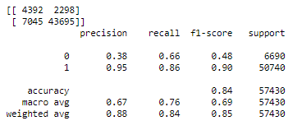

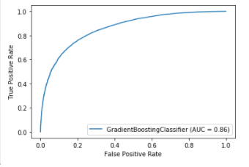

**CONCLUSION-**

**According to the performance metrics, Random Forest scores highest in accuracy. So, Random Forest looks like the best fit for this data.**

**https://www.imdb.com/search/title/?groups=top_100&ref_=adv_prv**

**https://whatismybrowser.com/w/YAGGX6W**